Filed

Date: ______________

Time: ________ am/pm

Clerk: _____________

|  |  |
| --- | --- |
| **IN THE**  **SUPREME COURT OF THE REPUBLIC OF PALAU**  **TRIAL DIVISION** | |
| __________________________________  Petitioner  vs.  ____  Respondent | Civil Action/DA Case No. ____________  Petition for Order for Protection  and Statement in Support Thereof |

|  |
| --- |
| 1. Petitioner ____________________________, is a resident of ________________________________.  (Name as listed in caption.) (State, Country.)   * Petitioner is a victim of domestic abuse committed by the respondent. * Petitioner is a member of a family or household, where  a minor person;  an incapacitated person;  a person physically unable to appear, is a victim of domestic abuse committed by the respondent. * Petitioner is a representative of an Agency of the Republic of Palau entitled to seek relief on behalf of the victim, who is  a minor person;  an incapacitated person;  a person physically unable to appear. |
| 2. Identification of Victim(s):   |  |  |  |  |  | | --- | --- | --- | --- | --- | | Name  (First, Middle, Last) | Age | Race | Sex | Mark ✓ if Resides with Respondent | |  |  |  |  |  | |  |  |  |  |  | |  |  |  |  |  | |  |  |  |  |  | |  |  |  |  |  | |
| 3. Identification of Respondent:   |  |  |  |  |  | | --- | --- | --- | --- | --- | | Alias | Age | Race | Sex | Residence  (State, Country) | |  |  |  |  |  | |
| 4. The victim’s relationship with the respondent is (Mark ✓all applicable):   * spouse or former spouse; * parent of a common child; * current or former cohabitant as intimate partner; * current or former dating relationship; * stepparent or stepchild; * current or former cohabitant as roommate; * in-law (current or former household member) * parent or child; * blood relation other than parent or child. Please specify _________________________. |
| 5. Other court cases or other restraining, protection or no-contact orders involving me, the victim and/or the respondent:   |  |  |  |  | | --- | --- | --- | --- | | Case No. | Case Name | Court | Date | |  |  |  |  | |  |  |  |  | |  |  |  |  | |
| 6. Check the box for each type of relief you are requesting and for each type of order you need:   * **Temporary:** I request an **Ex Parte “Temporary” Restraining Order for Protection**, to be issued without notice to respondent, for a period of _____ days. (Note: TRO may last up to 180 days or until a protective order issues.) * **Full:** I request a **“Full” Order for Protection,** following a hearing on notice to the   respondent.   |  |  |  | | --- | --- | --- | | Temporary (Yes or No) | Full (Yes or No) | RELIEF REQUESTED | |  |  | A court order requiring the respondent to stay away from the protected party and/or any member of the household | |  |  | A court order restraining the respondent from contacting, threatening, physically and/or sexually abusing the protected party | |  |  | A court order restraining the respondent from contacting, threatening, physically and/or sexually abusing any person residing at the protected party’s residence | |  |  | A court order restraining the respondent from entering and/or visiting the protected party’s residence | |  |  | A court order restraining the respondent from taking, concealing, removing, threatening, physically abusing, or otherwise disposing of any animal identified to the court as belonging to a household. | |  |  | A court order establishing temporary custody and/or visitations with regard to any minor children. | | N/A |  | A court order directing the respondent to participate in domestic violence intervention services. | |  |  | Other relief not referenced above necessary to prevent domestic abuse or a recurrence of abuse. Please specify: __________________________  _____________________________________________________________________________________________________________________. | |

***Statement:*** The respondent has committed acts of domestic abuse as follows. (Describe specific acts of domestic abuse and their approximate dates, beginning with the most recent act. You may want to include police responses.)

Describe the most recent abusive act, fear or threat of abuse, and why the temporary order should be entered today without notice to the respondent:

. (Continue on separate page if necessary.)

Describe the past incidents where you experienced abuse, where you were afraid of injury or where the respondent threatened to harm or kill you:

. (Continue on separate page if necessary.)

Describe any violence or threats towards children:

. (Continue on separate page if necessary.)

Describe any stalking behavior by respondent, including use of telephonic, audiovisual or electronic means to harass or monitor:

. (Continue on separate page if necessary.)

Describe any psychological abuse or malicious property damage:

. (Continue on separate page if necessary.)

Describe medical treatment you received and for what:

_______________________________________________________________________

_____________________________________________. (Continue on separate page if necessary.)

Describe any threats of suicide or suicidal behavior by the respondent:

. (Continue on separate page if necessary.)

Does the respondent own or possess firearms?  Yes  No

Does the respondent use firearms, weapons or objects to threaten or harm you? Please describe:

. (Continue on separate page if necessary.)

If you are requesting that the protection order last longer than one year, describe the reasons why:

. (Continue on separate page if necessary.)

Other:

. (Continue on separate page if necessary.)

Check box if substance abuse is involved:  alcohol  drugs  other.

I certify under penalty of perjury under the laws of the Republic of Palau that the foregoing is true and correct.

Dated: ___________________ ______________________________

Signature of Petitioner

Cont’d from page

Common Risk Assessment questionnaire

VICTIM

|  |  |
| --- | --- |
| **Risk factor** | **Explanation** |
|  |  |
| **Victim** |  |
|  |  |
| Pregnancy/new birth | Family violence often commences or intensifies during pregnancy and is |
|  | associated with increased rates of miscarriage, low birth weight, premature |
|  | birth, fetal injury and fetal death. Family violence during pregnancy is |
|  | regarded as a significant indicator of future harm to the woman and her child. |
|  |  |
| Depression/mental health | Victims with a mental illness may be more vulnerable to family violence |
| Issue | due to their inability to accurately assess their situation. |
|  |  |
| Drug and/or alcohol | Victims may use alcohol or other drugs to cope with the physical, emotional |
| misuse/abuse | or psychological effects of family violence, which can lead to increased |
|  | vulnerability. |
|  |  |
| Has ever verbalized or | Suicidal thoughts or attempts indicate that the victim is extremely vulnerable |
| had suicidal ideas or tried | and the situation has become critical. |
| to commit suicide |  |
|  |  |
| Isolation | A victim is more vulnerable if they are isolated from family, friends and other |
|  | social networks. Isolation also increases the likelihood of violence and is not |
|  | simply geographical. Other examples of isolation include cultural factors, |
|  | which may limit a new immigrant’s access to social supports; disabilities, |
|  | which may limit social interaction or support; and/or the perpetrator not |
|  | allowing the victim to have social interaction. |

PERPETRATOR

|  |  |
| --- | --- |
| **Risk factor** | **Explanation** |
|  |  |
| **Perpetrator** |  |
|  |  |
| Use of weapon in most | Use of a weapon indicates a high level of risk because previous behavior |
| recent event | is a likely predictor of future behavior. A weapon is defined as any tool used |
|  | by the perpetrator which can injure, kill or destroy property, including guns. |
|  |  |
| Access to weapons | Perpetrators who have access to weapons, particularly guns, are much more |
|  | likely to seriously injure or kill a victim than others without access to weapons. |
|  |  |
| Has ever harmed or | Psychological and emotional abuse has been found to be a good predictor |
| threatened to harm victim | of continued abuse, including physical abuse. Previous physical assaults |
|  | also predict future assaults. |
|  |  |
| Has ever tried to choke | Strangulation or choking is a common method used by male perpetrators |
| the victim | to kill female victims. |
|  |  |
| Has ever threatened to | Evidence suggests that a perpetrator’s threat to kill a victim is often genuine. |
| kill victim | . |
|  |  |
| Has ever harmed or | Evidence suggests that child abuse and family violence are likely to occur in |
| threatened to harm or kill | the same family. Children witnessing, hearing or being subjected to |
| Children | violence will be adversely affected and may develop behavioral and |
|  | emotional problems. |
|  |  |
| Has ever harmed or | Threats by the perpetrator to hurt or cause actual harm to family members |
| threatened to harm or kill | can be a way of controlling the victim through fear. |
| other family members |  |
|  |  |
| Has ever harmed or | A correlation between cruelty to animals and family violence is increasingly |
| threatened to harm or kill | being recognized. Because there is a direct link between family violence |
| pets or other animals | and pets being abused or killed, abuse or threats of abuse pets may be |
|  | used by perpetrators to control family members. |
| **Risk factor** | **Explanation** |
|  |  |
| **Perpetrator** cont’d |  |
|  |  |
| Has ever threatened or | Threats or attempts to commit suicide have been found to be a risk factor |
| tried to commit suicide | for murder–suicide. |
|  |  |
| Stalking of victim | Stalkers are more likely to be violent if they have had an intimate relationship |
|  | with the victim. Stalking, when coupled with physical assault, is strongly |
|  | connected to murder or attempted murder. Stalking behavior and obsessive |
|  | thinking are highly related behaviors. |
|  |  |
| Sexual assault of victim | Sexual assault includes when the perpetrator has forced the victim to have |
|  | sex against their will, coerced sexual activity or carried out unwanted sexual |
|  | touching. Women who report sexual assault are more likely to have a history |
|  | of family violence. |
|  |  |
| Previous or current | Breaching Intervention Order conditions indicates the defendant is not willing to |
| breach of Intervention | abide by the orders of a court. Such behavior should be considered a |
| Order | serious indicator of increased risk of future violence. |
|  |  |
| Drug and/or alcohol | Serious problems with illicit drug, alcohol or prescription drugs and inhalants |
| misuse/abuse | lead to impairment in social functioning and create a risk of family violence. |
|  | This includes temporary drug-induced psychosis. |
|  |  |
| Controlling behaviors | The perpetrator can exercise complete control over the victim’s activities by, |
|  | for example, telling the victim who they can be friends with, controlling how |
|  | much money the victim can access, and determining when the victim can see |
|  | friends and family and when the victim can use the car. Men who think they |
|  | ‘should be in charge’ are more likely to use various forms of violence against |
|  | their partner. |
|  |  |
| Unemployed | Unemployment is associated with an increased risk of lethal assault, and a |
|  | sudden change in employment status – such as being terminated and/or |
|  | retrenched – may be associated with increased risk. |
|  |  |
| Depression/mental health | Murder–suicide outcomes in family violence have been associated with |
| Issue | perpetrators who have mental health problems, particularly depression. |
|  |  |
| History of violent | Perpetrators with a history of violence are more likely to use violence against |
| Behavior | family members. This can occur even if the violence has not previously |
|  | been directed toward family members. Other victims may have included |
|  | strangers, acquaintances and/or police officers. The nature of the violence |
|  | may include credible threats or use of weapons, and attempted or actual |
|  | assaults. Violent men generally engage in more frequent and more severe |
|  | family violence than perpetrators who do not have a violent past. |
|  |  |
|  |  |
| **Relationship** |  |
|  |  |
| Separation | For women who are experiencing family violence, the high risk periods include |
|  | immediately prior to taking action, and during the initial stages of or |
|  | immediately after separation. Victims who stay with the perpetrator because |
|  | they are afraid to leave often accurately anticipate that leaving would increase |
|  | the risk of lethal assault. The data on ‘time-since-separation’ suggests |
|  | that women are particularly at risk within the first two months. |
|  |  |
| Escalation – increase in | Violence occurring more often or becoming worse has been found to be |
| severity and/or frequency | associated with lethal outcomes for victims. |
| of violence |  |
|  |  |
| Financial difficulties | Low income (less than that required to provide for basic needs) and financial |
|  |  |
|  | stress including a gambling addiction are risk factors for family violence. |

RISK ASSESSMENT TICK SHEET FOR COMPLETION BY WORKERS OR PARTIES

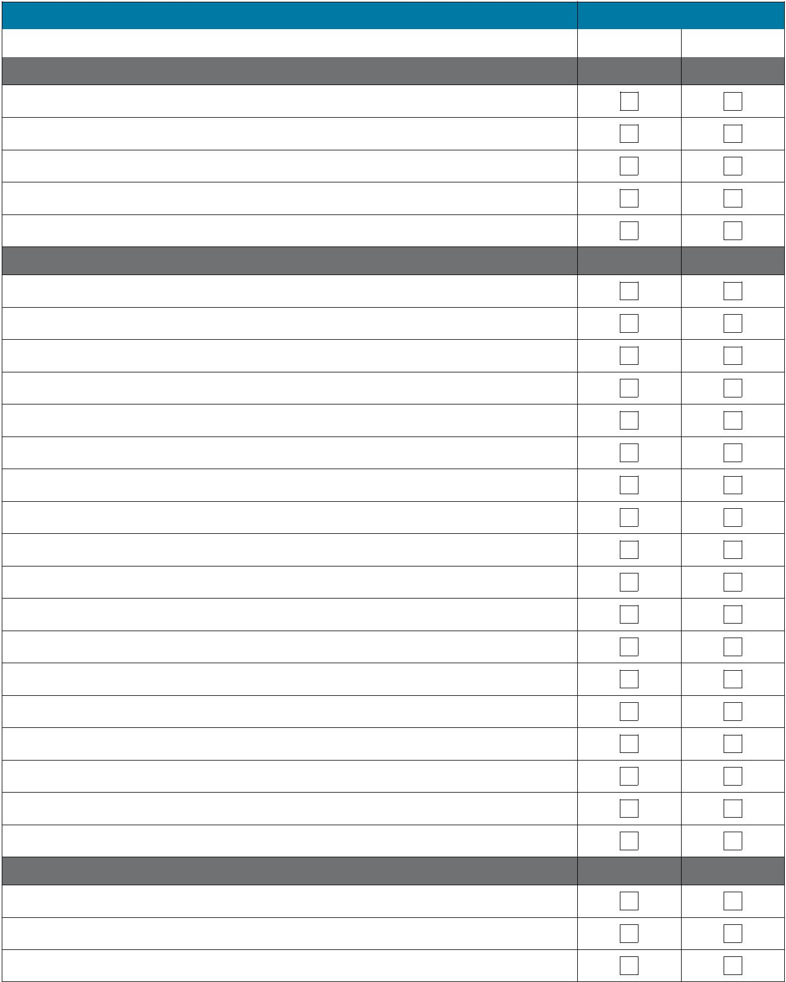

|  |  |  |
| --- | --- | --- |
| **Risk or vulnerability factor** | **Presence of factor** | |
|  |  |  |
|  | Yes | No |
| **Victim** |  |  |

Pregnancy/new birth*

Depression/ mental health issue

Drug and/or alcohol misuse/abuse

Has ever verbalized or had suicidal ideas or tried to commit suicide

Isolation

**Perpetrator**

Use of weapon in most recent event*

Access to weapons*

Has ever harmed or threatened to harm victim

Has ever tried to choke the victim*

Has ever threatened to kill victim*

Has ever harmed or threatened to harm or kill children*

Has ever harmed or threatened to harm or kill other family members

Has ever harmed or threatened to harm or kill pets or other animals*

Has ever threatened or tried to commit suicide*

Stalking of victim*

Sexual assault of victim*

Previous or current breach of intervention order

Drug and/or alcohol misuse/abuse*

Obsession/jealous behavior toward victim*

Controlling behavior*

Unemployed*

Depression/mental health issue#

History of violent behavior (not family violence)

**Relationship**

Recent separation*

Escalation – increase in severity and/or frequency of violence*

Financial difficulties

* May indicate an increased risk of the victim being killed or almost killed. # Mental health issues such as depression and paranoid psychosis, which focuses on the victim as hostile, are high risk when they are present in conjunction with other risk factors, particularly a previous history of violence. The presence of a mental health issue must be carefully considered in relation to the co-occurrence of other risk

CASE NO:________

**Palau Disability Questionnaire:**

1. Do you have difficulty seeing, even if wearing glasses?

|  |  |  |
| --- | --- | --- |
|  |  | Yes |
|  |  |  |
|  |  | No |

1. Do you have difficulty hearing, even if using a hearing aid?

|  |  |  |
| --- | --- | --- |
|  |  | Yes |
|  |  |  |
|  |  | No |

1. Do you have difficulty walking or climbing steps?

|  |  |  |
| --- | --- | --- |
|  |  | Yes |
|  |  |  |
|  |  | No |

1. Do you have difficulty remembering or concentrating?

|  |  |  |
| --- | --- | --- |
|  |  | Yes |
|  |  |  |
|  |  | No |

5. Do you have difficulty with your motor skills such as writing or lifting objects?

|  |  |  |
| --- | --- | --- |
|  |  | Yes |
|  |  |  |
|  |  | No |

1. Using your usual language, do you have difficulty communicating, for example understanding or being understood?

|  |  |  |
| --- | --- | --- |
|  |  | Yes |
|  |  |  |
|  |  | No |

**IN THE**

**SUPREME COURT OF THE REPUBLIC OF PALAU**

**TRIAL DIVISION**

**CIVIL ACTION/DA NO.______________**

**DOCKET STATEMENT**

|  |  |
| --- | --- |
| Petitioner(s) | Respondent(s) |
| Permanent Address:  **SEE CLERK OF COURT** | Permanent Address: |
| Current Address:  **SEE CLERK OF COURT** | Current Address: |
| Contact Numbers:  (Home) **SEE CLERK OF COURT**  (Work)  (Mobile) | Contact Numbers:  (Home)  (Work)  (Mobile) |
| Agency (If Applicable) | Attorney (If Applicable) |
| Attorney (If Applicable) |  |